**IFT 466 Advanced Computer Networks**

**Lab 4  
EIGRP – Configuration and DHCP**

After you complete each step, put a ‘√’ or ‘x’ in the completed box

**Objective**Setup a topology with DHCP and then enable the EIGRP protocol.

1. Setup up the following topology on Packet Tracer

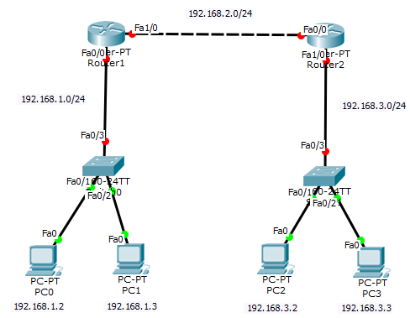



✓

1. We will configure R1 with an IP address on Fa0/0, rename the router and then create the DHCP pool from which the PCs will obtain their IP configuration details.

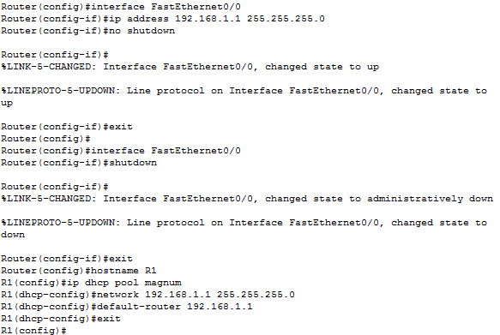



✓

1. Now go to PC0 and obtain the PC configuration via DHCP as shown below

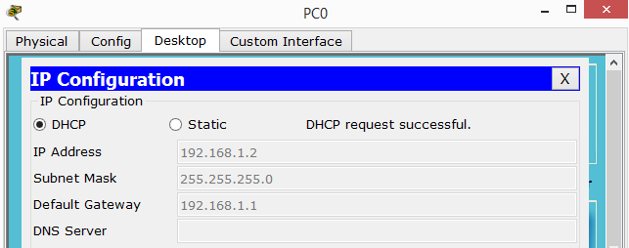



✓

1. Now the topology (192.168.1.0 LAN) has been updated

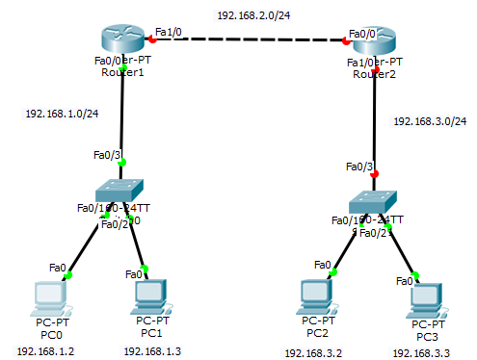



✓

1. Configure the Fa1/0 interface on R1, enable EIGRP and add the networks





✓

1. Now run the show ip interface brief and show ip protocols command to check our settings

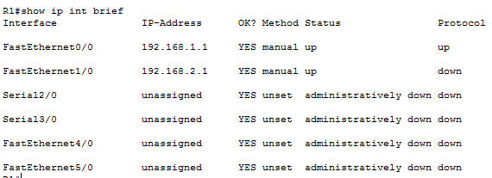

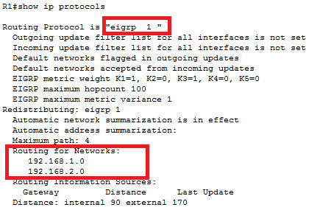



✓

1. Now we will configure R2 with the same commands we used to configure R1

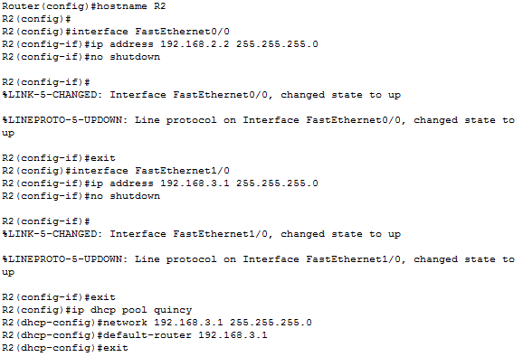



✓

1. Now go to PC2 and Pc3 and obtain the PC configuration via DHCP as you did with PC0/PC1



✓

1. Now we will enable EIGRP and add the networks to R2. Watch how the adjacency is formed when we add the network.

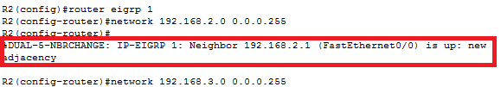



✓

1. Now we will run the show ip route command and R2 and the subnet (192.168.1.0) has been added.

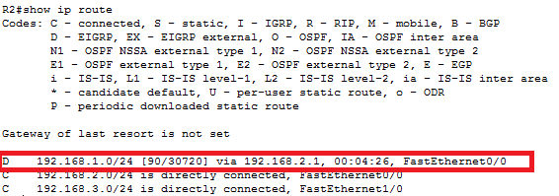



✓

1. Now run the show ip dhcp binding command to check our DHCP configuratoins

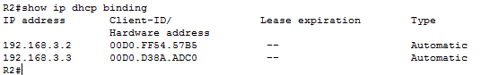



1. Now attempt to Ping from PC0 to PC 2

Did it work?

 ✓

If not, then troubleshoot to find out why.

